Logbook 5 Template (for offline log preparation)
Name: | Kaung Linn Aung
Week Date: | Part B -Meeting 1 of 4
(The above information is for you to keep track of which week this log is applicable for. This information is not required in the online logbook as the system will find your name, your supervisor’s name, and take the submission date, automatically. You must submit the online log in the relevant week. Logs cannot be backdated to missed weeks.)

Meeting date:  (please note if no meeting is planned this week) | Date and day  25/6/2026
Work Undertaken this week:  Not more than 500 words | State the work done from last meeting in Part A (after submission Project Outline) till now?  Hardware purchased and test run on bench. The Raspberry Pi 5 (8GB) was installed with Raspberry Pi OS and set up for headless use via Raspberry Pi Connect, eliminating the need for a separate monitor. The Raspberry Pi Camera Module 2 was tested with rpicam utility suite and an OpenCV pipeline was designed and tested for HSV colour thresholding and KCF feature-based object tracking. The MPU-6050 IMU was attached to the I²C bus of the Pi and the raw six-axis motion data was verified. The STM32 Nucleo-F411RE was enumerated over USB and its ST-LINK interface verified.  Firmware toolchain established. The following error occurred during the first development in the Arduino IDE: STM32 core v3.0.0: Removed the pin-argument HardwareSerial constructor needed to create a secondary UART. Development has been moved to Mbed Studio and Mbed OS 6.17.0 has been cloned from the official repository and linked as a shared library, instead of downgrading to a deprecated core version. A serial test firmware for the Nucleo-F411RE (PING/PONG) with a three-second heartbeat fail-safe has been written and a Python test script has been created for the Raspberry Pi. Master–slave link validation is planned for the next week.  The Bill of Materials (BOM) has been finalised for component selection and the BOM has been revised (see attached BOM, now with an acquisition-status column). Propulsion: One APISQUEEN X2 brushless ducted thruster (12-16V, 830KV, 2.1kg thrust, 7A continuous). The power was specified as an ONBO 3S 2800mAh 45C LiPo (XT60) which was chosen over a 4000mAh power pack to reduce the internal length requirement and to place dense mass low in the sled as passive keel ballast. The N20 geared motors driven by a TB6612FNG dual H-bridge are used for ballast actuation. An MS5837-30BA I²C pressure sensor is needed for depth sensing.  Take pictures of your item prepared to date.  Update your BOM Table  Hardware:  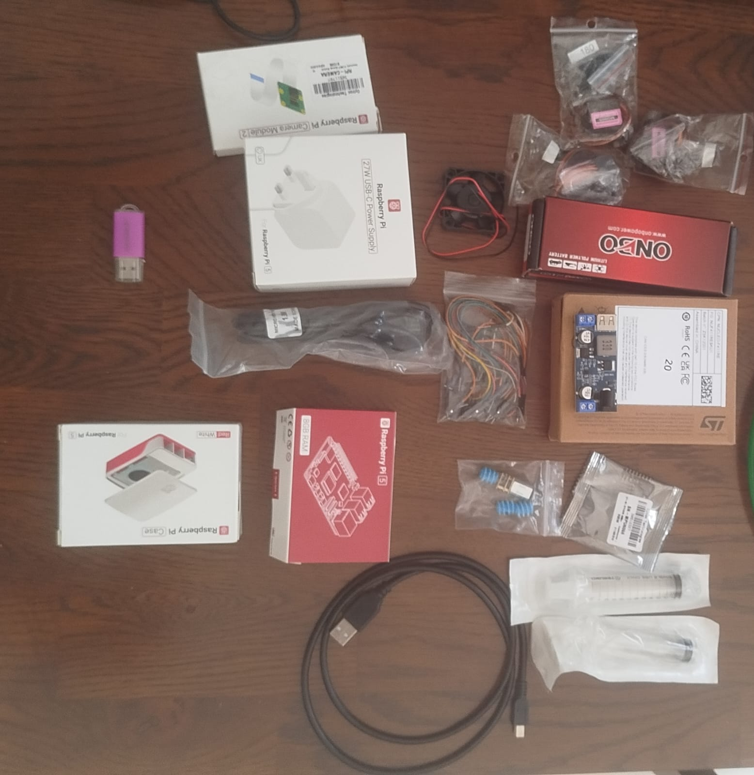  Figure 1 Hardwares Picture  Software installed on your laptop  - FreeCAD  - Autodesk Fusion 360  - Git  - Visual Studio Code  - Ubuntu Laptop  - Python  - Mbed Studio  Your Github link:  https://github.com/IceBerg-coder/IMP-AUV-Project
Problems encountered:  (Not more than 500 words | What are the challenges to your project Outline that you have made or going to make? Why?  1. Propulsion architecture – Three vectored thrusters changed to a single thruster with X configuration rudders. The Outline listed three brushless thrusters for differential-thrust steering, plus a dedicated vertical axis. This has been changed to a single thruster attached to the stern with four stern fins (X) and driven by two servos (yaw and pitch). The change will lower the propulsion cost from S$150 to S$25, reduce the number of penetrations of the hull from 3 to 1, and is more suitable for the torpedo-form cylindrical hull, as seen in the Outline reviewed micro-AUV, the HippoCampus. The compromise is that forward velocity determines the control surface authority, meaning that the vehicle cannot rotate on the spot or hold station and inspection manoeuvres must therefore be performed as a transit pass. The pitch authority of the rudders is supplemented by the active ballast system to provide depth control.  2. Servo sealing method. Waterproof hobby servos are splash-proof, not waterproof. Shaft seals also have a greater leakage potential than static or linear seals, and failure of the seals on the hull is the top risk on the project risk assessment. Both servos will thus be housed within the dry hull and connected to the outside fins by stainless pushrods through O-ring linear glands in the aft end-cap.  3. Internal length budget over. The Outline set the hull to be 110mm in diameter and 500mm in length. The revised Bill of Materials' component allocation is 680mm, which exceeds this envelope. The 2800mAh battery pack recovered 45mm, while the two rudder servos consume about 45mm internally which the externally mounted thrusters do not consume. Resolution needs to be improved by either increasing the length of the hull or replacing the smaller servos or by improving the allocation estimates, which are currently conservative and are based on serial rather than parallel placement of the servos. The final length of the hull will be determined from the completed Fusion 360 assembly.  4. Camera interface. A USB camera module was outlined in the Outline. The Raspberry Pi Camera Module 2 on the CSI interface is now used instead, since it was already available and has lower latency capture with built-in support from picamera2. The hardware block diagram should be updated as per the above.  5. Firmware toolchain. Arduino IDE / STM32CubeIDE were mentioned in the Outline. In the work done this week, development has shifted to Mbed Studio, because of a compilation problem with the current Arduino STM32 core.  6. Pressure sensor procurement. Local suppliers do not stock the MS5837-30BA, but only barometric sensors that saturate at about 1m. The bare surface-mount die is available from local distributors and would need to be fabricated on a PCB and reflowed. This means that an overseas break out module order is necessary, which in turn influences the integration of sensors.
Tasks agreed for upcoming week before the next meeting | What are your plan actions/task until the next progress meeting that are agreed with your supervisor  Task 1: Demonstration of Master – Slave communication. The PING/PONG link test will be performed between the Raspberry Pi 5 and the STM32 Nucleo-F411RE, via USB and then via the GPIO UART wiring that will be used in the final build (8/10 pins of Pi to D2/D8 pins of Nucleo with the common ground). Reply integrity and round trip latency will be recorded and the three second failsafe for reply will be tested by breaking the link and ensuring that the secondary MCU enters failsafe. A photo of the terminal output and a wiring photo will be taken as evidence.  Task 2: Demonstration of an active ballast system. The N20 geared motor will be attached to the syringe plunger using a threaded rod and a guided carriage with the help of the lead-screw ballast mechanism, which will be modelled in Fusion 360 and printed. The TB6612FNG driver will be connected to the STM32 to control the plungers in both directions and with limits set in firmware. The water volume to be displaced on full intake and discharge travel will be illustrated on the bench and the volume of water displaced will be measured against the time of actuation to provide a calibration value for the depth control loop.
Figures:  (Upload image files in the online Log Form, but feel free to keep notes here about which images you intend to upload. Use “Figure Caption” information as the filenames, e.g., “Figure 1 – A screenshot of the initial constrained Sketch in CATIA.jpg”) | Your can upload to Github and share the link  No need to past the pictures or videos here  - Update Hardware Block diagram of your system  Figure 2 Updated Hardware Block Diagram  - Key software codes/modules that need to be developed  Secondary microcontroller (STM32 Nucleo-F411RE, C++ / Mbed OS 6.17.0)  - Serial link and command parser — UART at 115200 baud with the master; setpoints down, telemetry up. Test firmware written.  - Heartbeat failsafe — If the master packets are lost, returns the thruster to neutral, centres rudders and discharges ballast for positive buoyancy. With a 3 second timeout.  - Actuator output: 50Hz PWM to ESC and 2 rudder servos, throttle ramp limiter to avoid current spikes when switching directions.  - Rudder mixing — converted yaw and pitch to the two positions demanded by the X-fin configuration.  - Complementary filtering and pressure to depth conversion I²C sensor drivers: MPU-6050 (0x68) and MS5837-30BA (0x76).  - Bidirectional N20 control with timed travel limits (TA) and volume-per-second calibration (N20) via the TB6612FNG.  - Depth PID controller — closed loop depth control through the ballast system, pitch control as secondary control. Gains achieved in tank testing.  - Leak monitor — monitors both leak sensors and initiates emergency surfacing without master.  The Master processor is a Raspberry Pi 5 with Python 3. Master processor is a Raspberry Pi 5 using Python 3.  - Capture with picamera2 and OpenCV tracking. Both HSV thresholding and KCF tracking were bench-tested.  - Serial communication — UART packet construction and parsing of telemetry. Test implementation written.  - Mission sequencer — runs the pre-programmed waypoint and depth sequence, checks for returned telemetry.  - Data logging – video and timestamped telemetry to onboard microSD.  - Any Quality and Regulatory issues addressed?  - Battery containment: 3S LiPo is contained in an unvented sealed hull (row 2 risk assessment). Charged outside of the hull at 1C in a fire-resistant bag, not when sealed. Raised the main fuse from 30A to 40A.  - Electrical isolation: dual regulated 5 V rails ensure that the Pi 5 is isolated from thruster transients, which means that if it fails, it will not disable the MCU failsafe. ESC BEC is disconnected and common ground is present.  - The highest rated hazard is hull integrity. Rudder steering requires two penetrations, therefore linear pushrod seals were selected instead of rotating shaft seals. Emergency surfacing is activated by two leak sensors. All powered trials are preceded by submersion testing.  - Test facility: depth validation requires a test tank of at least 0.6 m depth and 3 m clear run, while for rudder steering, a forward motion is required. Lab tank availability to be confirmed, otherwise an inflatable pool will be required, floor loading and drainage to be agreed with the lab engineer. Thruster is fresh water only.  - An updated/improved version of your system sketch  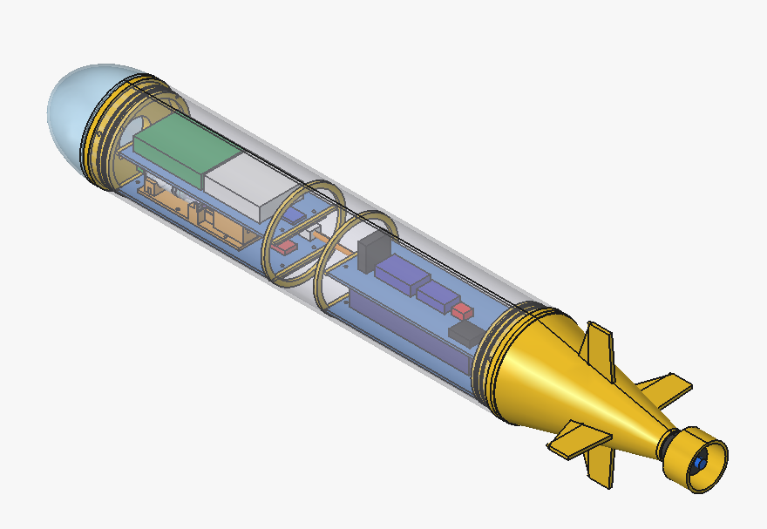  Figure 3 Updated Version of AUV Prototype model

